Specifying Software Requirements

Project: CMS: Clinic Management System

Revision 1

Document file

Date | Revision | Author | Verified dep. quality.
11/11/2025 | Rev 1. | Paradigm | 

Document validated by the parties on date: 11/11/2025

By the customer | By the supplier company
Fdo. D./ Mrs. | Fdo. D./Dña

Content
Document file 2
Content 3
1 Introduction 4
1.1 Purpose 4
1.2 Scope 4
1.3 Staff involved
1.4 Definitions, acronyms and abbreviations 4
1.5 References 4
1.6 Summary
2 Overview 5
2.1 Product Outlook 5
2.2 Product Functionality 5
2.3 User Features 5
2.4 Restrictions 5
2.5 Assumptions and dependencies
2.6 Foreseeable evolution of the system
3 Specific Requirements 6
3.1 Common Interface Requirements
3.1.1 User Interfaces
3.1.2 Hardware Interfaces
3.1.3 Software Interfaces
3.1.4 Communication Interfaces
3.2 Functional Requirements 7
3.2.1 Functional Requirement 1 7
3.2.2 Functional Requirement 2 7
3.2.3 Functional Requirement 3 7
3.2.4 Functional Requirement n
3.3 Non-functional requirements 8
3.3.1 Performance Requirements 8
3.3.2 Safety 8
3.3.3 Reliability 8
3.3.4 Availability 8
3.3.5 Maintainability 9
3.3.6 Portability 9
4 Appendices 9

Introduction
Product Identification

The purpose of this document is to define and specify the requirements for the development of a Clinic Management System (CMS).
This system is designed to streamline and automate the administrative and clinical operations of a medical clinic. It will provide functionalities for patient registration, medical records, healthcare professionals information, billing, appointment scheduling and notifications.
The CMS aims to improve the efficiency and accuracy of clinical workflows, enhance patient satisfaction, and ensure secure and reliable handling of sensitive medical data.

Definitions, acronyms and abbreviations

CMS: Clinic Management System.
RF: Functional Requirement.
RNF: Non-functional requirement.
ID: Identification.

References
Reference | Title | Route | Date | Author
[Ref1] | System Description | /path/description | 2025-10-28 | Development Team
[Ref2] | Medical Record Structure | /route/record | 2025-10-25 | Clinical Director.
[Ref3] | Health Data Privacy Policy | /route/data | 2025-10-20 | IT Department

Overview

Product Outlook
The CMS is a comprehensive and modular software product designed to automate and manage the administrative and clinical operations of a medical clinic.

Product Functionality
The CMS shall provide the following core functionalities:

- Patient Information.
- Patient Information.
- Billing Module.
- Medical Records.
- Appointment Scheduling.
- Appointment Notifications.
- Prescription Management.

User Features
User Type | Patient | Doctor | Receptionist | Administrator
Formation | Basic or higher education | Higher education: Medical degree. | Technical or administrative education. | Higher or technical education in management.
Skills | Basic computer or mobile device usage | Medical record management, prescription creation, and patient data analysis. | System data entry and appointment coordination. | System management, user administration, and data analysis.
Activities | Register and update personal data, schedule appointments, view medical records and prescriptions, and make payments | Access and update patient medical records, manage appointments, and issue prescriptions. | Register patients, manage doctor schedules, handle billing processes, and send appointment notifications. | Oversee clinic operations, manage user permissions, generate reports, and ensure data security and system maintenance.

Restrictions
- Development methodologies: An agile methodology will be used.
- Programming languages: Languages such as Java will be preferred.
- Safety Standards: Compliance with brigade safety regulations.
- Hardware: The system must be compatible with standard mobile devices and workstations.
- Operating system: Compatible with Windows and Android.

Assumption and dependency
The system will assume that each user has a unique ID, email, and password to access the platform.
When a new account is created, the user will by default be registered as a patient.
If it is necessary to add other user types such as doctor, receptionist, or administrator, an administrator will have the authority to modify the account type from their control panel.
The main administrator account will be pre-registered in the system database for security reasons and cannot be deleted or duplicated.
The system also depends on the availability of a stable internet connection, secure authentication services, and the proper configuration of the database server to ensure correct operation.

Future requirements
In future versions of the CMS, new functionalities will be incorporated to improve the system’s performance and user experience. A new module will be developed to manage online payments, allowing users to add or subtract balance directly within their accounts, since this process will initially be handled externally.
Additionally, a component will be implemented for the generation of detailed billing and payment reports to facilitate financial tracking. The system will also include features to notify patients and administrators when an electronic payment has been successfully completed and to automatically issue a digital invoice for each transaction.

External Interfaces
It will interact with external systems and tools to enhance functionality and data accuracy. It will integrate a calendar system to manage and control appointment scheduling, allowing configuration of available time slots and date ranges for patient reservations.

Specific Requirements

Requirement Number | RF 1
Requirement Name | Patient Information Management
Guy | Requirement | Restriction
Source of Requirement | Administrative staff
Priority of the requirement | High/Essential | Medium/Desired | Low/Optional

Requirement Number | RF 2
Requirement Name | Doctor Information Management
Guy | Requirement | Restriction
Source of Requirement | Administrative staff
Priority of the requirement | High/Essential | Medium/Desired | Low/Optional

Requirement Number | RF 3
Requirement Name | Billing Module
Guy | Requirement | Restriction
Source of Requirement | Administrative staff
Priority of the requirement | High/Essential | Medium/Desired | Low/Optional

Requirement Number | RF 4
Requirement Name | Medical Records
Guy | Requirement | Restriction
Source of Requirement | Administrative staff
Priority of the requirement | High/Essential | Medium/Desired | Low/Optional

Requirement Number | RF 5
Requirement Name | Appointment Scheduling
Guy | Requirement | Restriction
Source of Requirement | Administrative staff
Priority of the requirement | High/Essential | Medium/Desired | Low/Optional

Requirement Number | RF 6
Requirement Name | Appointment Notifications
Guy | Requirement | Restriction
Source of Requirement | Administrative staff
Priority of the requirement | High/Essential | Medium/Desired | Low/Optional

Requirement Number | RF 7
Requirement Name | Prescription Management
Guy | Requirement | Restriction
Source of Requirement | Administrative staff
Priority of the requirement | High/Essential | Medium/Desired | Low/Optional

Requirement Number | RNF 1
Requirement Name | Secure Data Handling
Guy | Requirement | Restriction
Source of Requirement | Technical Staff
Priority of the requirement | High/Essential | Medium/Desired | Low/Optional

Requirement Number | RNF 2
Requirement Name | Ensure system availability
Guy | Requirement | Restriction
Source of Requirement | Technical Staff
Priority of the requirement | High/Essential | Medium/Desired | Low/Optional

Requirement Number | RNF 3
Requirement Name | Facilitate maintenance
Guy | Requirement | Restriction
Source of Requirement | Technical Staff
Priority of the requirement | High/Essential | Medium/Desired | Low/Optional

Requirement Number | RNF 4
Requirement Name | Failure Measurement and Logging
Guy | Requirement | Restriction
Source of Requirement | Technical Staff
Priority of the requirement | High/Essential | Medium/Desired | Low/Optional

Functional Requirements
.

Functional Requirement 1
- Requirement Number: RF 1
- Requirement Name: Patient Information Management.
- Type: Requirement
- Requirement Source: Administrative Staff
- Requirement Priority: High
- Description: The system shall allow the registration, storage, and updating of patient information, including personal details, contact information, and medical history. Authorized users must be able to retrieve and modify this data securely when necessary.

Functional Requirement 2
- Requirement Number: RF 2
- Requirement Name: Doctor Information Management
- Type: Requirement
- Requirement Source: Administrative Staff
- Requirement Priority: High
- Description: The system shall store and manage information about doctors, including their names, specialties, availability, and contact details. It shall allow administrators to update schedules and assign patients accordingly.

Functional Requirement 3
- Requirement Number: RF 3
- Requirement Name: Billing Module
- Type: Requirement
- Requirement Source: Administrative Staff
- Requirement Priority: High
- Description: The system shall generate and manage invoices for medical services, process electronic payments, and record billing history for each patient. It must support integration with external payment gateways and insurance systems.

Functional Requirement 4
- Requirement Number: RF 4
- Requirement Name: Medical Records
- Type: Requirement
- Requirement Source: Administrative Staff
- Requirement Priority: High
- Description: The system shall store patients’ medical histories, including diagnoses, treatments, laboratory results, and prescriptions. It must ensure that medical data is accessible only to authorized healthcare professionals.

Functional Requirement 5
- Requirement Number: RF 5
- Requirement Name: Appointment Scheduling
- Type: Requirement
- Requirement Source: Administrative Staff
- Requirement Priority: High
- Description: The system shall provide functionality for scheduling, rescheduling, and canceling patient appointments. It must manage doctor availability and avoid conflicts in time allocation.

Functional Requirement 6
- Requirement Number: RF 6
- Requirement Name: Appointment Notifications
- Type: Requirement
- Requirement Source: Administrative Staff
- Requirement Priority: High
- Description: The system shall send automated notifications to patients and doctors regarding scheduled, rescheduled, or canceled appointments via email or SMS.

Functional Requirement 7
- Requirement Number: RF 7
- Requirement Name: Prescription Management
- Type: Requirement
- Requirement Source: Administrative Staff
- Requirement Priority: High
- Description: The system shall allow doctors to issue, update, and store electronic prescriptions that can be viewed by patients and pharmacists within the clinic.

Non-functional requirements

Performance Requirements
- Performance Requirements
- Requirement Number: RNF 1
- Requirement Name: Secure Data Handling
- Type: Requirement
- Requirement Source: Technical Staff
- Requirement Priority: High
- Description: The system must efficiently manage simultaneous access by multiple users without significant delays.

Availability
- Requirement Number: RNF 2
- Requirement Name: Ensure System Availability
- Type: Requirement
- Requirement Source: Technical Staff
- Requirement Priority: High
- Description: The system must maintain an uptime of at least 99.5% during operating hours. Maintenance windows should be scheduled in advance to minimize disruptions to users.

Maintainability
- Requirement Number: RNF 3
- Requirement Name: Measure failure
- Type: Requirement
- Requirement Source: Technical Staff
- Requirement Priority: Medium
- Description: The system must be designed for easy maintenance, allowing technical staff to perform updates, debugging, and backups without affecting normal operations or data integrity.

Reliability
- Requirement Number: RNF 4
- Requirement Name: Failure Measurement and Logging
- Type: Requirement
- Requirement Source: Administrative Staff
- Requirement Priority: Medium
- Description: The system must include mechanisms to detect, log, and report failures automatically.

Appendices
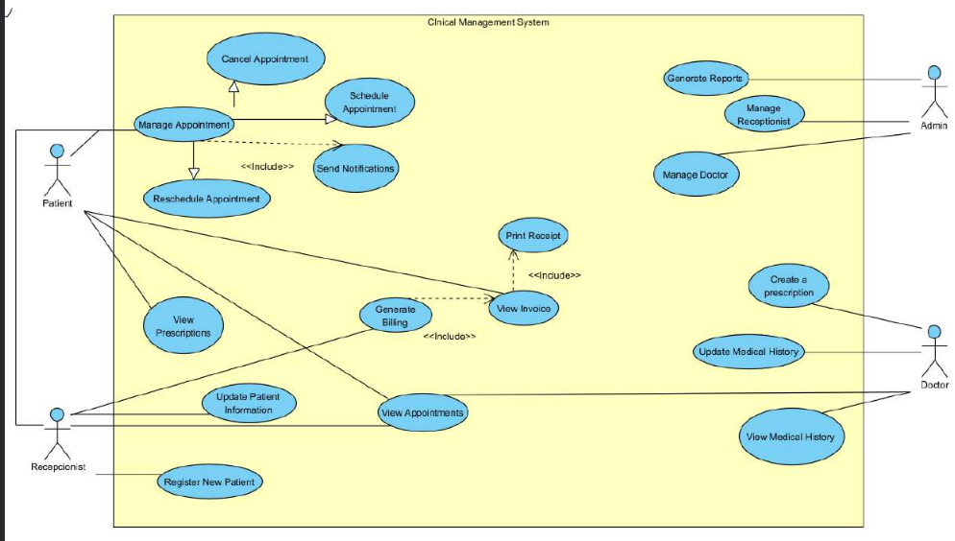
Illustration 1: Use case diagram
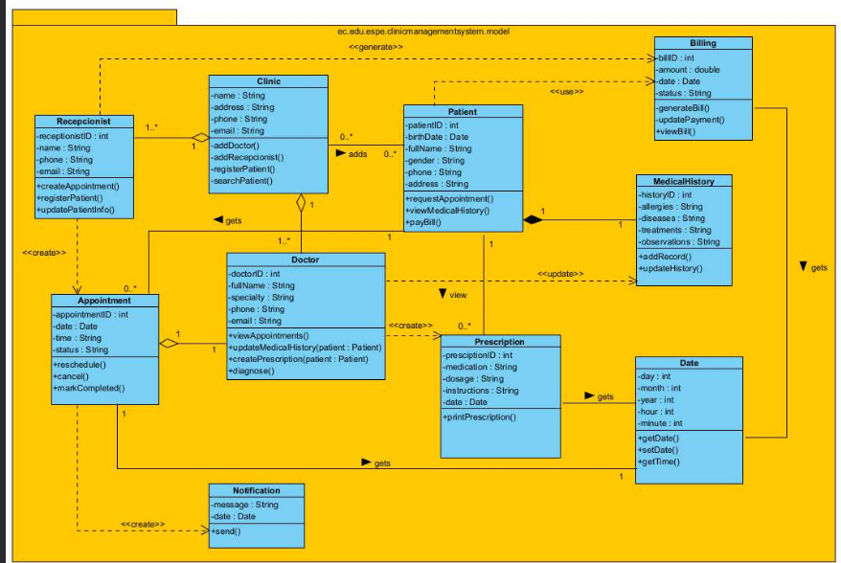
Illustration 2:Class diagram

